

REQUEST FOR PROPOSALS: TRAVELING DISC GOLF HISTORY EXHIBIT

The Steady Ed Fund of the Disc Golf Foundation and the Professional Disc Golf Association invite proposals for hosting a traveling exhibit of disc golf historical artifacts. We are seeking institutions with a mission of promoting the sport of disc golf to host the traveling disc golf history exhibit for a 4-6 month stay.

In June 2015, an exhibit of rare and historic golf discs and interpretive display cases was created through the cooperation of the DGF, the PDGA, Lavone Wolfe and Farina Headrick (widow of the late Ed Headrick). The exhibit premiered August 3, 2015 at the Western Pennsylvania Sports Museum during the opening ceremonies of the 2015 PDGA Pro Disc Golf World Championships in Pittsburgh, PA, and ran for three months to great reviews.

Proposals require a secure viewing space for approximately 100 square feet of free-standing exhibit (a four-sided aluminum framing system of 7’x7’x6’ sides that holds four 48”x36” wood-framed shadow box display cases with lockable acrylic hinged doors, four interpretive banner stands, and an Ed Headrick prototype “Pole Hole” basket).

The entire exhibit, including padded and protective Pelican cases for 64 rare and historic flying discs, the pole hole (pedestal pictured below is NOT included) interpretive banner stands, and display cases, are packed in a 8’x4’x4’ shipping crate that weighs approximately 1300 pounds. Receiving the delivery crate requires a forklift or lift-gate loading dock.

Proposals require the exhibitor show a certificate of property insurance to cover the artifacts and display, and provide a detail of security measures during the exhibition run.

Artifacts in the exhibit are on loan from collections of Lavone Wolfe, Ed Headrick Museum, Disc Golf Hall of Fame and others. Shipping costs are covered by the Professional Disc Golf Association. Display and shipping cases were funded through the Steady Ed Fund of the Disc Golf Foundation.

Proposals including photos and/or floor plan for the space to host the exhibit, a 250-word description of how exhibit will be promoted and used to feature the history of the sport of disc golf, and a proposed time table for the exhibition run.

Proposals must be submitted to:

J. Gary Dropcho
Treasurer, Disc Golf Foundation
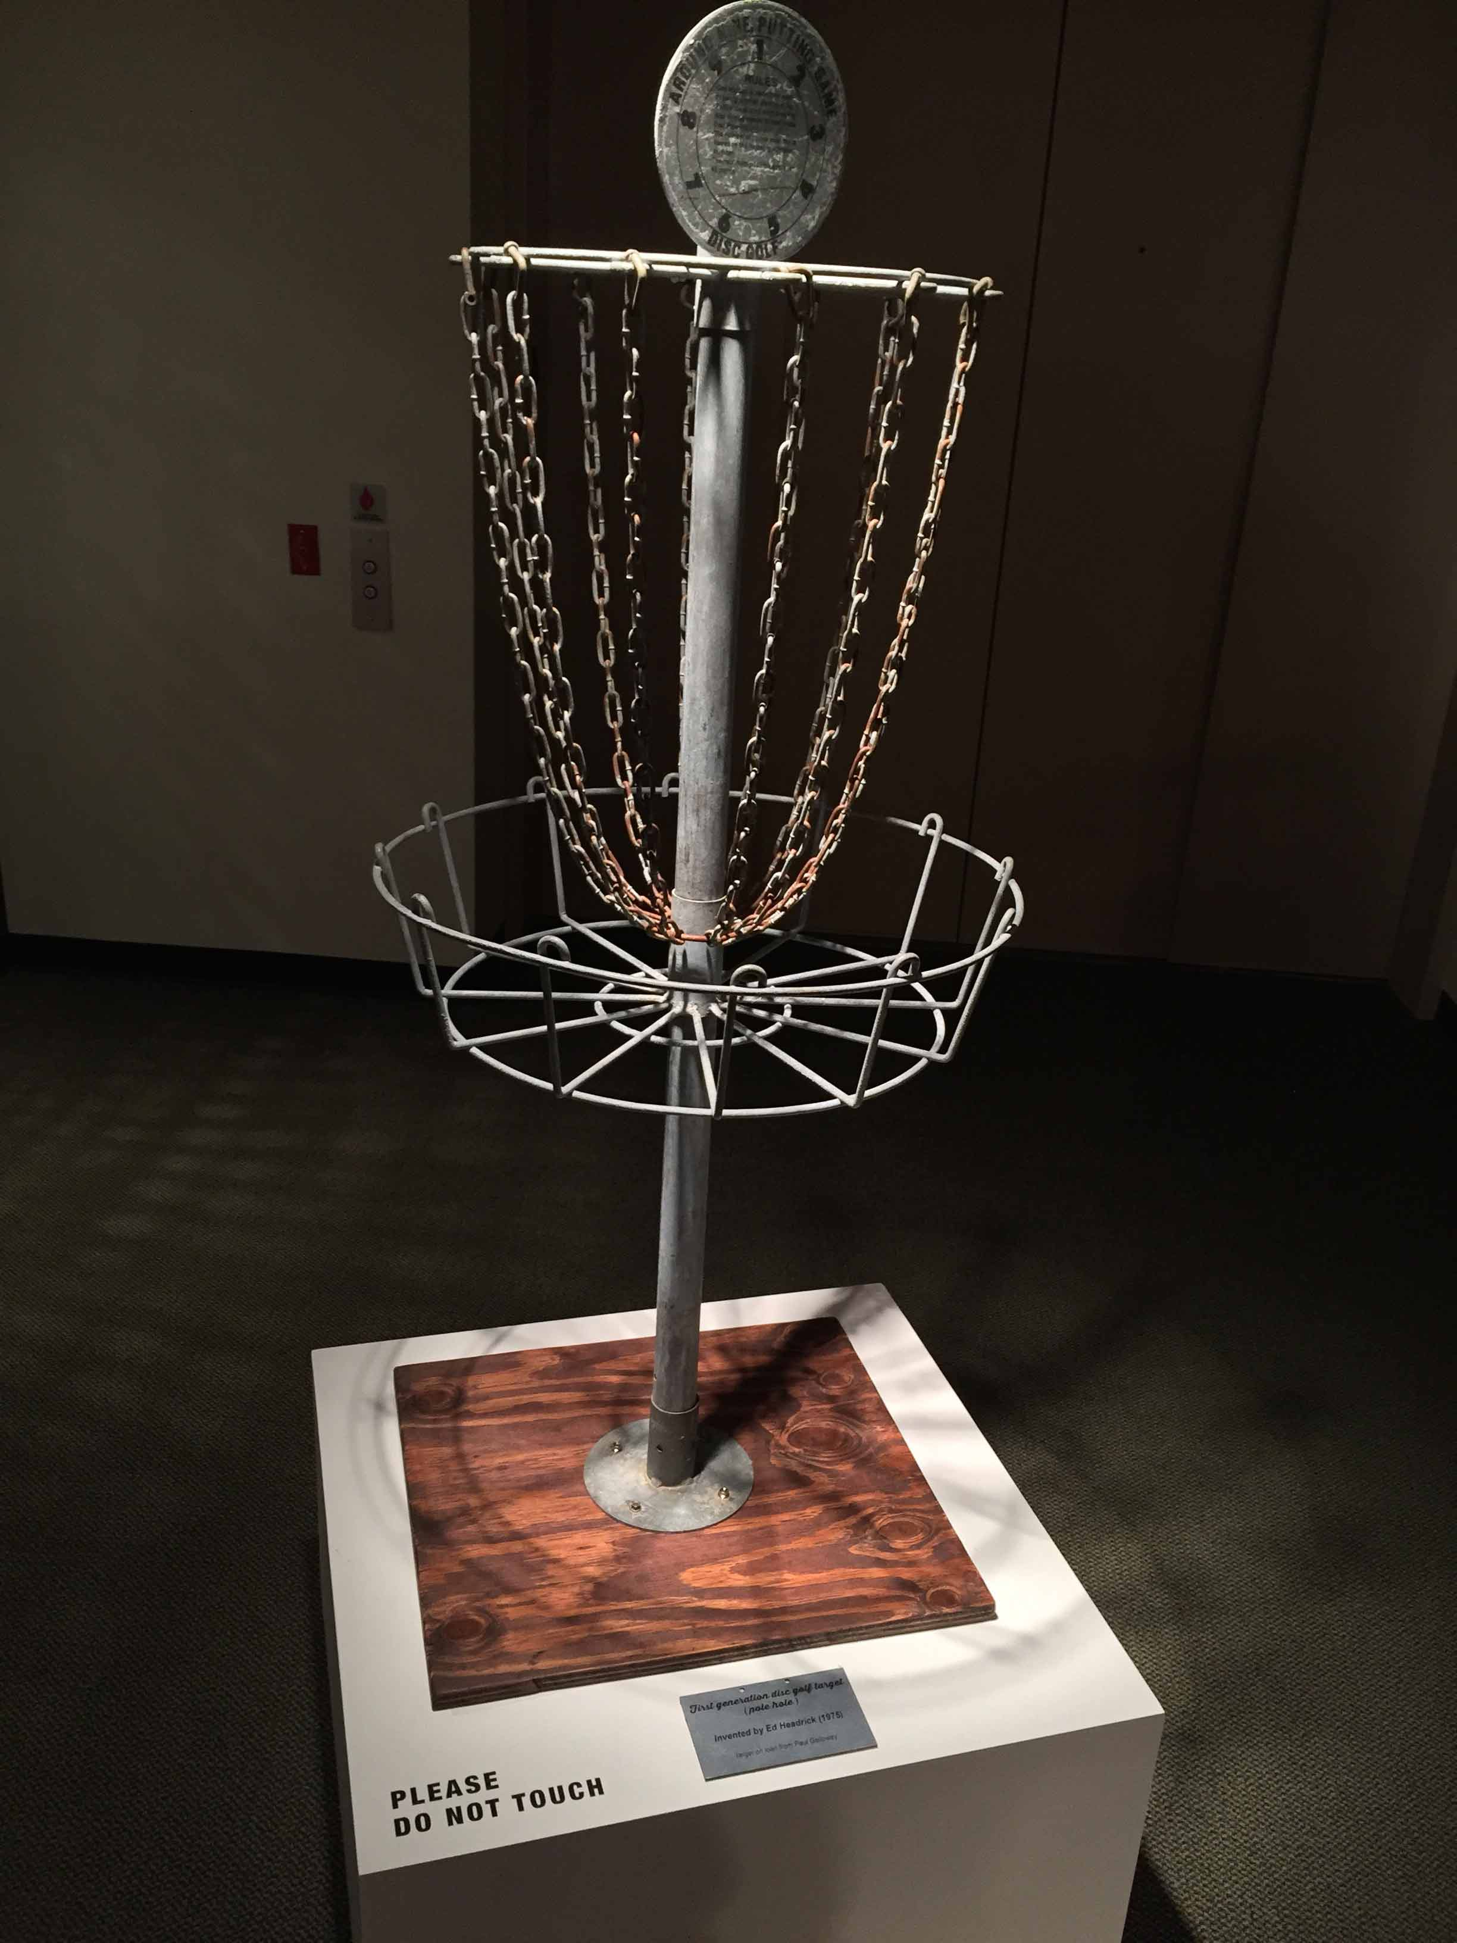
141 Maple Drive
Wexford, PA 15090
724-766-6121
dropcho@consolidated.net

Prototype Pole Hole (pedestal NOT included in traveling exhibit):

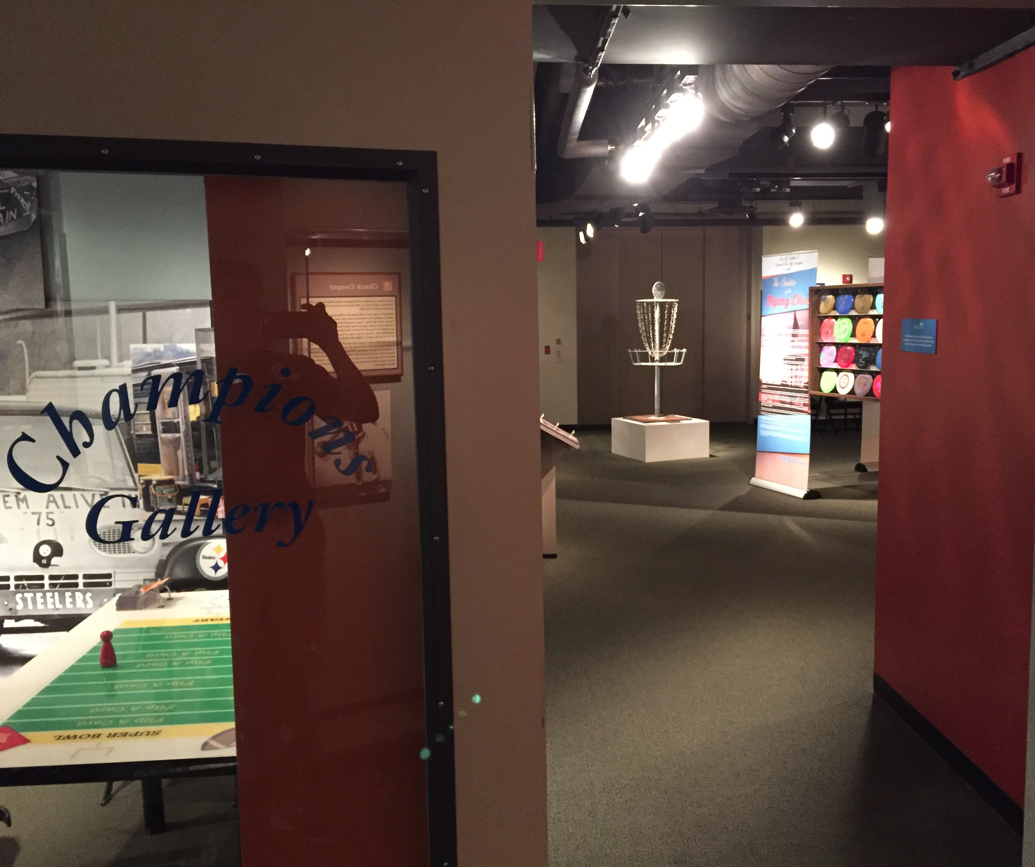

Entrance to Champions Gallery of Western PA Sports Museum where Disc Golf History Exhibit debuted in August 2015:

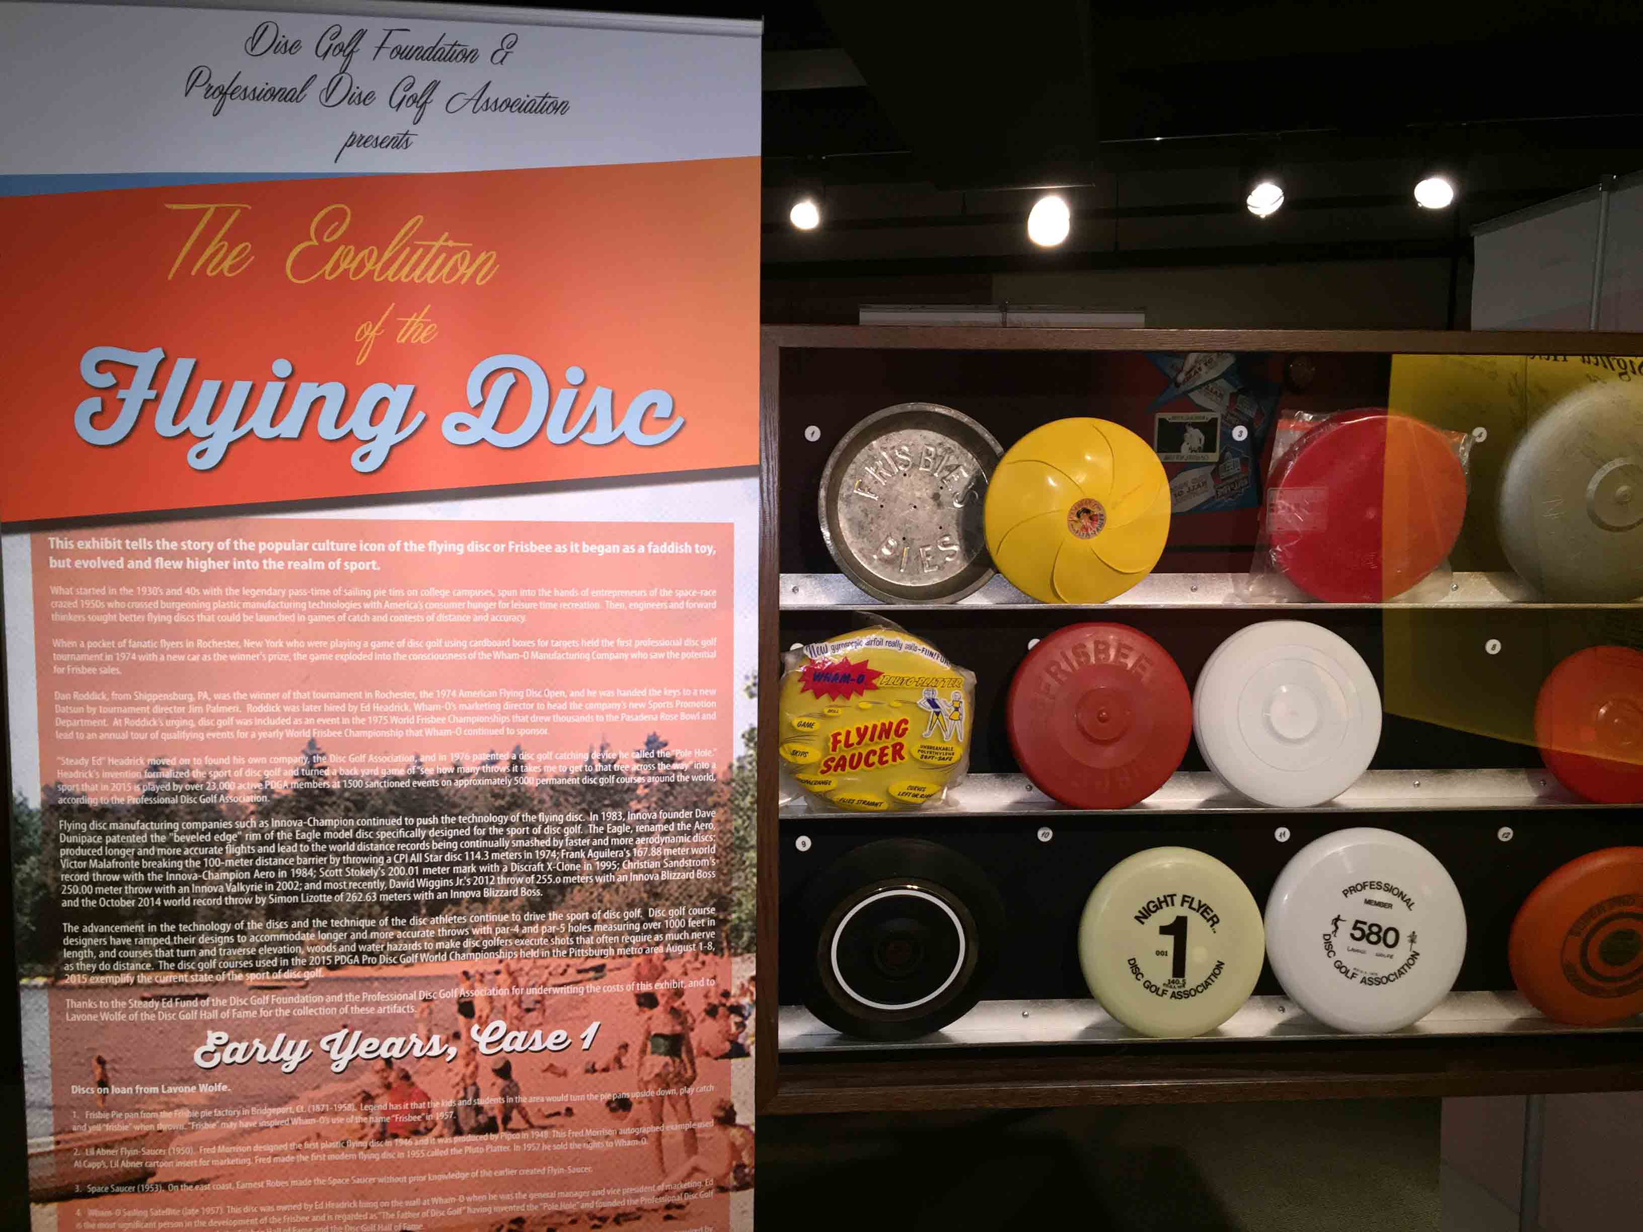
Case 1 and interpretive banner stand:

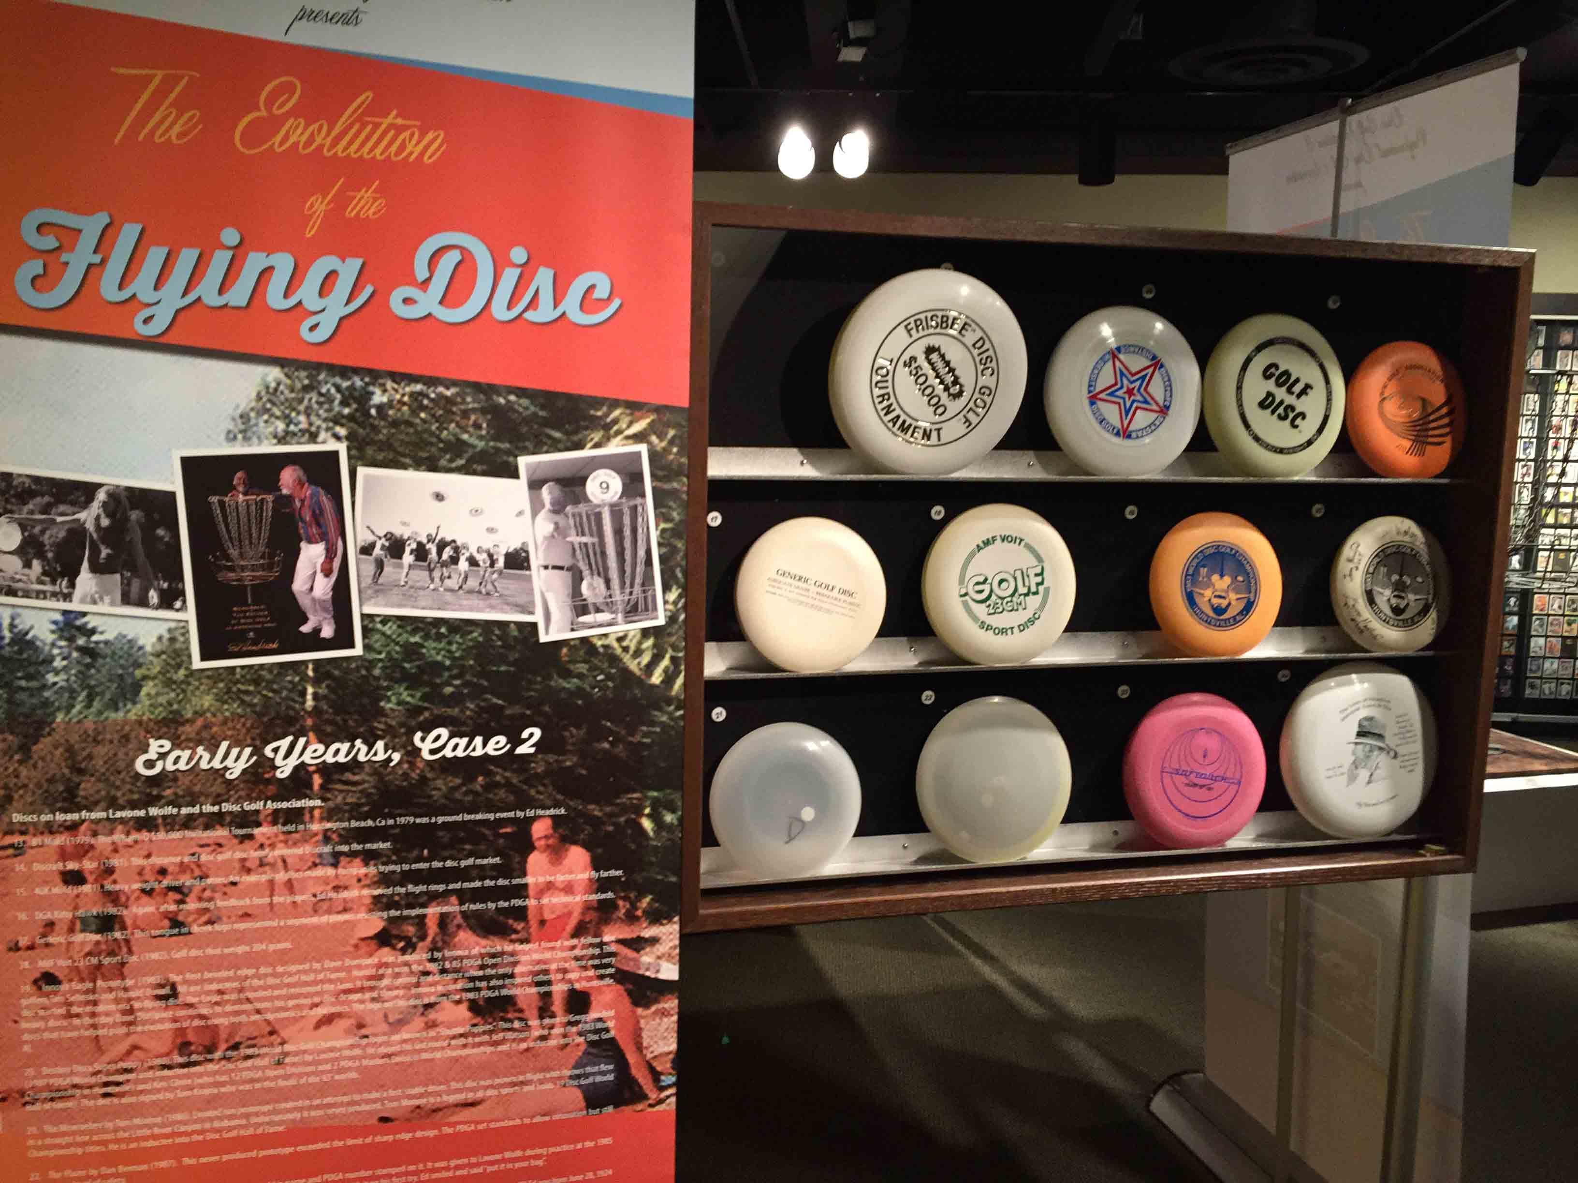
Case 2 and interpretive banner stand:

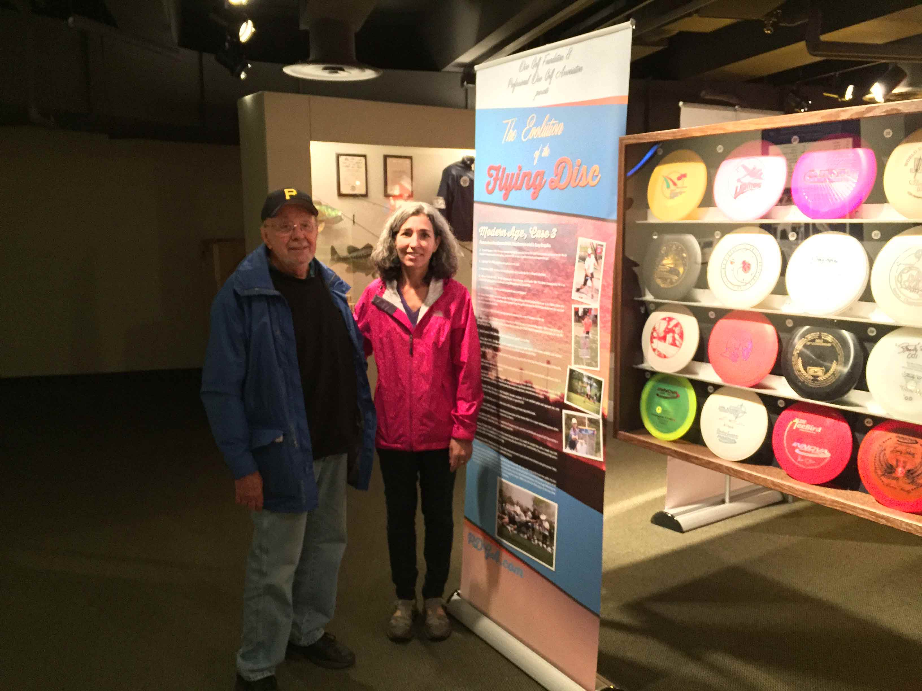
Case 3, interpretive banner stand and human scale:

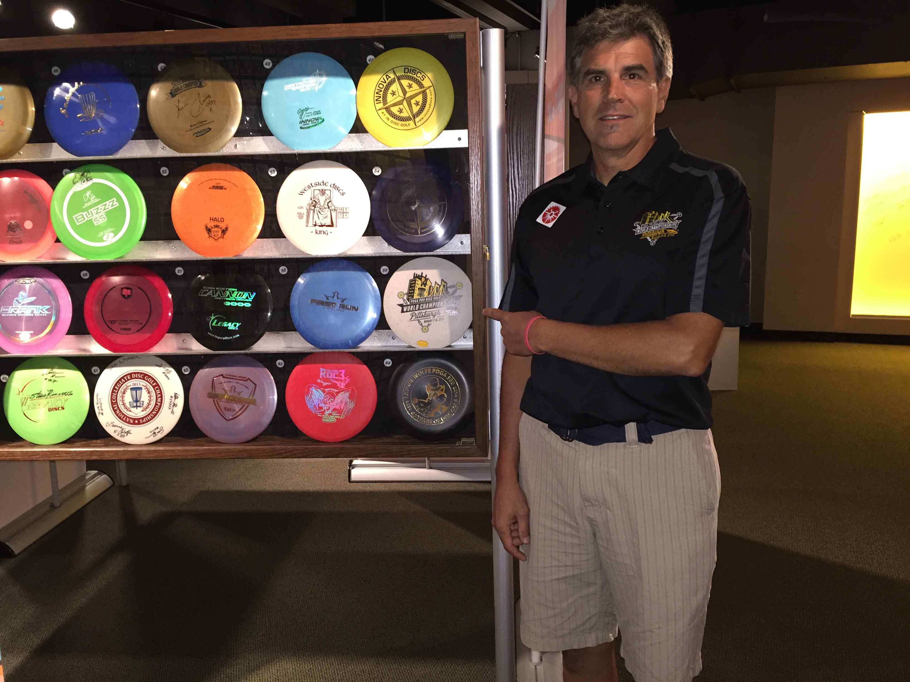

Case 4 and human scale

